INDDEX: 22425132

Q1a)
The crab’s data frame has 200 rows and 8 columns, describing 5 morphological measurements on 50 crabs each of two-colour forms and both sexes, of the species Leptograpsus variegatus collected at Fremantle, W. Australia.
Q1b) Data structure of Data set Crabs from Package MASS
str(MYDATA1)
'data.frame': 200 obs. of 8 variables:
$ sp : Factor w/ 2 levels "B","O": 1 1 1 1 1 1 1 1 1 1 ...
$ sex : Factor w/ 2 levels "F","M": 2 2 2 2 2 2 2 2 2 2 ...
$ index: int 1 2 3 4 5 6 7 8 9 10 ...
$ FL : num 8.1 8.8 9.2 9.6 9.8 10.8 11.1 11.6 11.8 11.8 ...
$ RW : num 6.7 7.7 7.8 7.9 8 9 9.9 9.1 9.6 10.5 ...
$ CL : num 16.1 18.1 19 20.1 20.3 23 23.8 24.5 24.2 25.2 ...
$ CW : num 19 20.8 22.4 23.1 23 26.5 27.1 28.4 27.8 29.3 ...
$ BD : num 7 7.4 7.7 8.2 8.2 9.8 9.8 10.4 9.7 10.3 ...

Q1c Frequency distribution for species and sex
variable | frequency
Specie-blue | 100
Specie-orange | 100
Female | 100
male | 100

ctab1<-table(MYDATA1$sp,MYDATA1$sex)
barplot(ctab1,beside = T,legend=T,col = rainbow(4),lwd=2,
main = "barplot for sex and species")

Q1d) barplot showing the distribution species and sex status
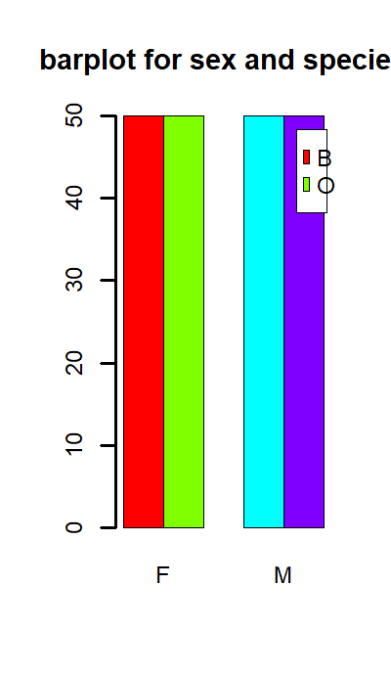
1Qe: Balanced
Since all the groups have equal number of frequencies (100 observation each), we can infer that the data is balance across the four groups.
Question2
Q2a) side by side boxplot of body dept (BD) for the four groups(sex and species)
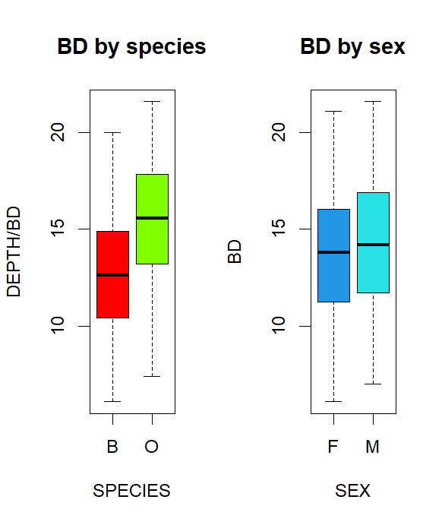

b) There were no outliers of body dept between the four groups. Also, all the categories in each group appear to be normally distributed as their first quarters and their 3Qur have the same shape as illustrated from the above boxplot. The median values divide the 1QUr and the 3Qur into equal parts across the four groups. Hence, body dept appear to be normally distributed across the four species. However, the median body dept of specie orange is greater than species blue. For the case of sex, the median body dept of male is quite higher (but can’t justify its significance). Variability in blue and female body dept are also quite greater than orange and male respectively.
Q3a) histogram showing the distribution of carapace length (CL) for each species
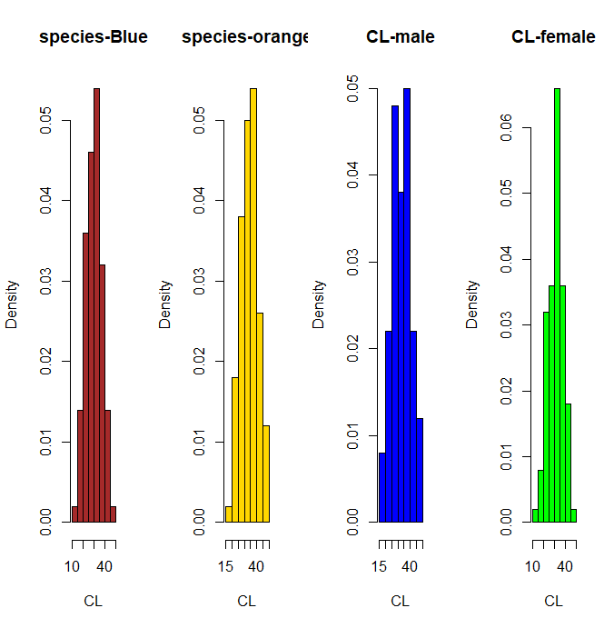

Q3b)
Carapace length in the blue species appears to be quite normally distributed by slight positively skewed with skewness value 0.03(~0). The modal value of CL in blue is 27.3 which different from its mean and median values. For orange, the modal CL is 31.6 which is different from its mean and median. Its not normally distribued since its skewness is -0.15(negatively ). but visually appears normal. For male, the skewness is -0.08 and modal value of 29.2. Hence not normally distributed. For female, negatively skewed(-0.13) and mode of 34.1 which is different its mean and median. Hence Cl IS not normally distributed in females.

Q5a) relationsip between FL and on other measurement(RW,CL,CW AND bd)
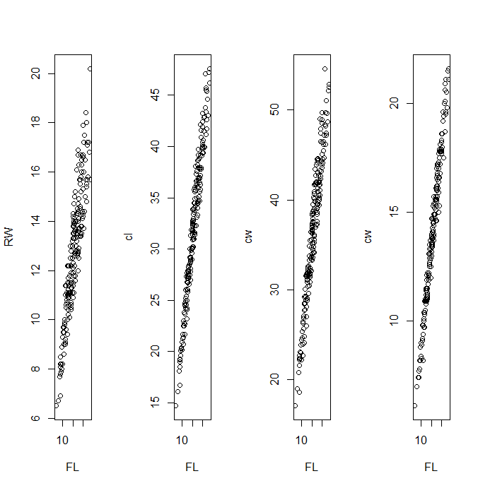
Relationsip between Cl and on other measurement(CW AND bd)

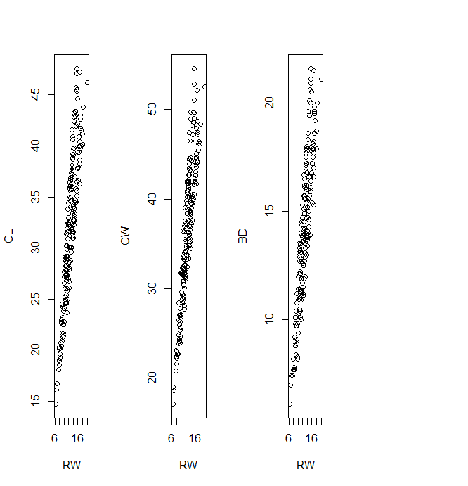
Q5b correlation output
cor(MYDATA1[4:8])
FL RW CL CW BD
FL 1.0000000 0.9069876 0.9788418 0.9649558 0.9876272
RW 0.9069876 1.0000000 0.8927430 0.9004021 0.8892054
CL 0.9788418 0.8927430 1.0000000 0.9950225 0.9832038
CW 0.9649558 0.9004021 0.9950225 1.0000000 0.9678117
BD 0.9876272 0.8892054 0.9832038 0.9678117 1.0000000

There is strong positive relationship among variables.
Q6)
The dataset crabs is a data frame with 8 variables. Two are categorical and the rest being numeric. There is a strong positive relationship among the variables used for the measurement. CL is not normally distributed among the four group.

